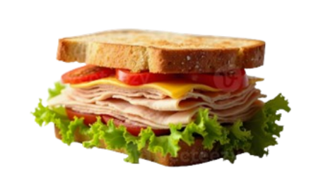
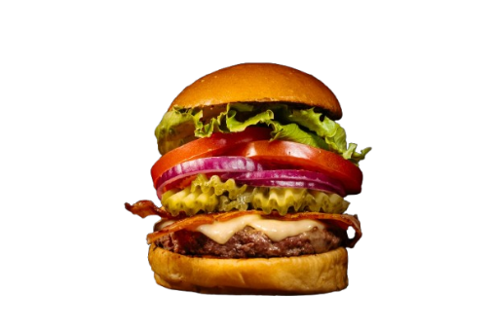
-$19
-$23
-$20
-$18

SANDWICH MENU
- Cheese Sandwich
- American Sandwich
- Greek Sandwich
- Meat Sandwich

-$19
-$23
-$20
-$18

- Cheese Burger
- American Burger
- Greek Burger
- Meat Burger
BURGER MENU
FOOD MENU

